School Nurse Talking Points
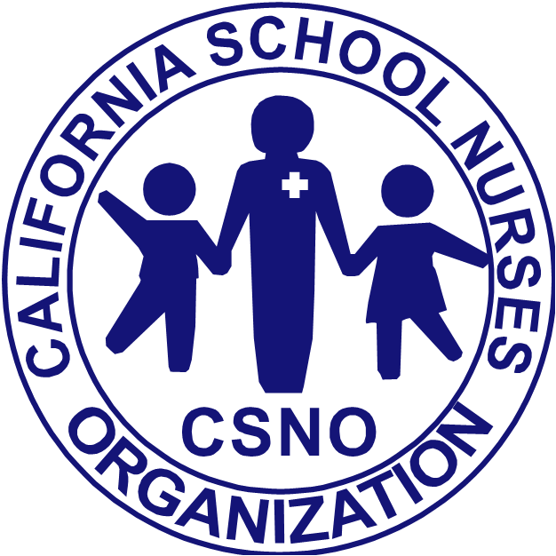
- School Districts are working hand in hand with the California Department of Public Health and local Public Health Officers.
- Notifications will soon be distributed or are being distributed to parents about the measles.
- Measles is a highly contagious and serious situation.
- If your child has not been immunized, it is important to contact your health care provider for additional information and vaccine availability.
- If you or your family members have any signs or symptoms of the measles, please stay home and contact your health care provider immediately as well as the school so we may alert others.
- Signs and Symptoms of the measles include:
Measles typically begins with
- high fever,
- cough,
- runny nose (coryza), and
- red, watery eyes (conjunctivitis).
- In the event of a case of measles in our school community, students that have not been vaccinated will be required to stay home until notice from the public health officer.
- Young infants and children, pregnant women and individuals that are immunocompromised with leukemia, cancer or HIV should avoid social situations where there may be cases of measles. Please contact your physician for further information.

